LITTLE NIPPERS
W6 SPRINT
REGATTA

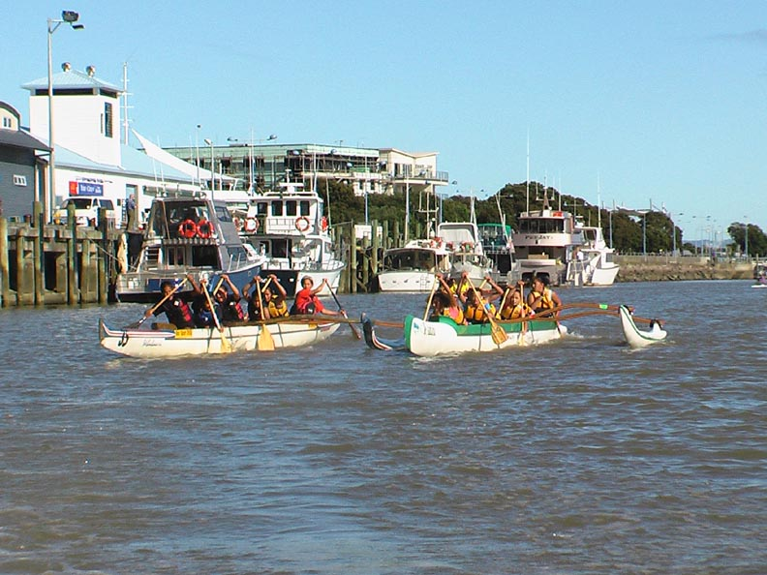

Hosted by
Tarawera Outrigger Canoe Club

Race 1 J16 Boys 500m Heat 1/ 2 Placing Time

3 Waka Tane Tuatara Waka Ama Club 1 1:52:81
1 Tumanako Turangawaewae Waka Sports 2 2:16:54
2 Rangatahi Turangawaewae Waka Sports 3 2:18:05

Race 2 J16 Girls 500m Heat 1/ 2 Placing Time

3 Wharemanaaki Turangawaewae Waka Sports 1 2:20:28
4 Rangimahora Tarawera Outrigger Canoe Club 2 2:22:78
1 Hawaiiki Tu Tuatara Waka Ama Club 3 2:24:17
2 Rimaeka Turangawaewae Waka Sports 4 2:26:56

Race 3 Midget Boys 250m Heat 1/ 2 Placing Time

2 Te Mata Turangawaewae Waka Sports 1 2:58:18
4 O Te Enua Turangawaewae Waka Sports 2 3:06:15
3 Team Pupuaruhe Tuatara Waka Ama Club 3 3:12:56
1 Tarawera Tarawera Outrigger Canoe Club 4 3:30:46

Race 4 Intermediate Boys 500m Heat 1/ 2 Placing Time

2 Tarawera Stingrays Tarawera Outrigger Canoe Club 1 2:20:56
3 Moanaroa Cruisers Tuatara Waka Ama Club 2 2:32:02
4 Emore Turangawaewae Waka Sports 3 2:39:39
1 Te Puna Turangawaewae Waka Sports 4 2:42:46

Race 5 Midget Girls 250m Heat 1/ 2 Placing Time

4 Iwi Morehu Tuatara Waka Ama Club 1 1:18:51
3 Te Ahurewa Turangawaewae Waka Sports 2 1:22:41
1 Manukatutahi Tarawera Outrigger Canoe Club 3 1:27:04
2 Team Maumoana Tuatara Waka Ama Club 4 1:43:05

Race 6 Intermediate Girls 500m Heat 1/ 4 Placing Time

1 Team Patuwai Tuatara Waka Ama Club 1 2:23:50
2 Ohinemataroa Tarawera Outrigger Canoe Club 2 2:24:54
3 Kimiora Turangawaewae Waka Sports 3 2:34:54

Race 7 Intermediate Girls 500m Heat 2/ 4 Placing Time

1 Whareroa Turangawaewae Waka Sports 1 2:33:46
2 Team Ngai Te Hapu Tuatara Waka Ama Club 2 3:08:40

Race 8 J16 Boys 1000m Heat 1/ 1 Placing Time

1 Waka Tane Tuatara Waka Ama Club 1 4:36:25
3 Tumanako Turangawaewae Waka Sports 2 5:36:00
2 Rangatahi Turangawaewae Waka Sports 3 4:48:93

Race 9 J16 Girls 1000m Heat 1/ 2 Placing Time

1 Wharemanaaki Turangawaewae Waka Sports 1 6:09:33
2 Rangimahora Tarawera Outrigger Canoe Club DQ 5:42:86

Race 10 J16 Girls 1000m Heat 2/ 2 Placing Time

2 Hawaiiki Tu Tuatara Waka Ama Club 1 5:06:07
1 Rimaeka Turangawaewae Waka Sports 2 5:37:38

Race 11 Intermediate Boys 1000m Heat 1/ 2 Placing Time

2 Tarawera Stingrays Tarawera Outrigger Canoe Club 1 5:31:27
1 Te Puna Turangawaewae Waka Sports 2 6:20:69

Race 12 Intermediate Boys 1000m Heat 2/ 2 Placing Time

1 Moanaroa Cruisers Tuatara Waka Ama Club 1 6:09:30
2 Emore Turangawaewae Waka Sports 2 6:18:04

Race 13 Intermediate Girls 1000m Heat 1/ 2 Placing Time

2 Team Patuwai Tuatara Waka Ama Club 1 5:42:85
1 Kimiora Turangawaewae Waka Sports 2 5:45:95
3 Whareroa Turangawaewae Waka Sports 3 6:50:12

Race 14 Intermediate Girls 1000m Heat 2/ 2 Placing Time

2 Ohinemataroa Tarawera Outrigger Canoe Club 1 6:16:00
1 Team Ngai Te Hapu Tuatara Waka Ama Club 2 7:55:07

Race 15 Midget Girls 500m Heat 1/ 1 Placing Time

1 Iwi Morehu Tuatara Waka Ama Club 1 3:01:01
3 Te Ahurewa Turangawaewae Waka Sports 2 3:02:27
2 Manukatutahi Tarawera Outrigger Canoe Club 3 3:37:81
4 Team Maumoana Tuatara Waka Ama Club 4 4:00:90

Race 16 Midget Boys 500m Heat 1/ 1 Placing Time

3 Te Mata Turangawaewae Waka Sports 1 2:35:11
4 Team Pupuaruhe Tuatara Waka Ama Club 2 2:47:05
1 O Te Enua Turangawaewae Waka Sports 3 2:49:42
2 Tarawera Tarawera Outrigger Canoe Club 4 3:08:28

Race 17 J16 Boys 500m Heat 2/2 Placing Time

2 Waka Tane Tuatara Waka Ama Club 1 1:29:84
3 Tumanako Turangawaewae Waka Sports 2 1:37:94
1 Rangatahi Turangawaewae Waka Sports 3 1:51:69

Race 18 J16 Girls 500m Heat 2/2 Placing Time

4 Hawaiiki Tu Tuatara Waka Ama Club 1 1:56:54
3 Rimaeka Turangawaewae Waka Sports 2 2:03:60
1 Wharemanaaki Turangawaewae Waka Sports 3 2:15:84
2 Rangimahora Tarawera Outrigger Canoe Club 4 2:20:64

Race 19 Midget Boys 250m Heat 2/2 Placing Time

3 Te Mata Turangawaewae Waka Sports 1 1:05:90
4 Tarawera Tarawera Outrigger Canoe Club 2 1:10:06
1 O Te Enua Turangawaewae Waka Sports 3 1:13:32
2 Team Pupuaruhe Tuatara Waka Ama Club 4 1:13:85

Race 20 Intermediate Boys 500m Heat 2/ 2 Placing Time

4 Te Puna Turangawaewae Waka Sports 1 2:01:46
3 Tarawera Stingrays Tarawera Outrigger Canoe Club 2 2:05:44
1 Moanaroa Cruisers Tuatara Waka Ama Club 3 2:06:85
2 Emore Turangawaewae Waka Sports 4 2:16:20

Race 21 Midget Girls 250m Heat 2/ 2 Placing Time

2 Iwi Morehu Tuatara Waka Ama Club 1 1:14:31
3 Manukatutahi Tarawera Outrigger Canoe Club 2 1:16:21
1 Te Ahurewa Turangawaewae 3 1:17:30
4 Team Maumoana Tuatara Waka Ama Club 4 1:24:04

Race 22 Intermediate Girls 500m Heat 3/ 4 Placing Time

3 Ohinemataroa Tarawera Outrigger Canoe Club 1 2:18:13
1 Kimiora Turangawaewae Waka Sports 2 2:20:48
2 Team Ngai Te Hapu Tuatara Waka Ama Club 3 2:42:86

Race 23 Intermediate Girls 500m Heat 4/ 4 Placing Time

1 Team Patuwai Tuatara Waka Ama Club 1 2:16:42
2 Whareroa Turangawaewae Waka Sports 2 2:20:64

Race 24 Midget Boys 500m Grand Final Placing Time

2 Te Mata Turangawaewae Waka Sports 1 2:13:42
4 O Te Enua Turangawaewae Waka Sports 2 2:21:86
3 Team Pupuaruhe Tuatara Waka Ama Club 3 2:26:01
1 Tarawera Tarawera Outrigger Canoe Club 4 2:47:32

Race 25 J16 Boys 1000m Grand Final Placing Time

2 Waka Tane Tuatara Waka Ama Club 1 4:52:36
1 Tumanako Turangawaewae Waka Sports 2 5:41:97
3 Rangatahi Turangawaewae Waka Sports 3 5:48:96

Race 26 Midget Girls 500m Grand Final Placing Time

3 Te Ahurewa Turangawaewae Waka Sports 1 2:20:44
4 Manukatutahi Tarawera Outrigger Canoe Club 2 2:28:81
2 Iwi Morehu Tuatara Waka Ama Club 3 2:36:37
1 Team Maumoana Tuatara Waka Ama Club DNS

Race 27 J16 Girls 1000m Grand Final Placing Time

3 Rimaeka Turangawaewae Waka Sports 1 5:41:74
2 Hawaiiki Tu Tuatara Waka Ama 2 5:49:16
1 Wharemanaaki Turangawaewae Waka Sports 3 7:24:89

Race 28 Intermediate Boys 1000m Grand Final Placing Time

2 Tarawera Stingrays Tarawera Outrigger Canoe Club 1 5:48:56
3 Moanaroa Cruisers Tuatara Waka Ama Club 2 5:57:57
1 Emore Turangawaewae Waka Sports 3 6:39:84

Race 29 Intermediate Girls 1000m Grand Final Placing Time

3 Kimiora Turangawaewae Waka Sports 1 5:57:13
2 Team Patuwai Tuatara Waka Ama Club 2 6:08:96
1 Ohinemataroa DQ Tarawera Outrigger Canoe Club 3 7:01:64

Race 30 Midget Girls 250m Grand Final Placing Time

4 Manukatutahi Tarawera Outrigger Canoe Club 1 1:05:66
2 Iwi Morehu Tuatara Waka Ama Club 2 1:08:39
3 Te Ahurewa Turangawaewae Waka Sports 3 1:11:69
1 Team Maumoana Tuatara Waka Ama Club DNS

Race 31 J16 Girls 500m Grand Final Placing Time

3 Rimaeka Turangawaewae Waka Sports 1 1:54:57
2 Hawaiiki Tu Tuatara Waka Ama Club 2 1:54:59
1 Wharemanaaki Turangawaewae Waka Sports DNS
4 Rangimahora Tarawera Outrigger Canoe Club DNS

Race 32 Midget Boys 250m Grand Final Placing Time

1 Tarawera Tarawera Outrigger Canoe Club 1 1:02:49
3 Team Pupuaruhe Tuatara Waka Ama Club 2 1:02:95
2 Te Mata Turangawaewae Waka Sports 3 1:04:44
4 O Te Enua Turangawaewae Waka Sports DNS

Race 33 Intermediate Girls 500m Grand Final Placing Time

3 Team Patuwai Tuatara Waka Ama Club 1 1:55:26
2 Kimiora Turangawaewae Waka Sports 2 1:56:19
4 Ohinemataroa Tarawera Outrigger Canoe Club 3 1:56:48
1 Whareroa Turangawaewae Waka Sports 4 2:06:65
5 Team Ngai Te Hapu Tuatara Waka Ama Club 5 2:09:89

Race 34 Intermediate Boys 500m Grand Final Placing Time

3 Tarawera Stingrays Tarawera Outrigger Canoe Club 1 1:52:82
2 Moanaroa Cruisers Tuatara Waka Ama Club 2 1:57:43
4 Te Puna Turangawaewae Waka Sports 3 2:00:15
1 Emore Turangawaewae Waka Sports 4 2:15:13

Race 35 J16 Boys 500m Grand Final Placing Time

2 Waka Tane Tuatara Waka Ama Club 1 1:34:60
3 Rangatahi Turangawaewae Waka Sports 2 1:49:62
1 Tumanako Turangawaewae Waka Sports 3 1:50:08

