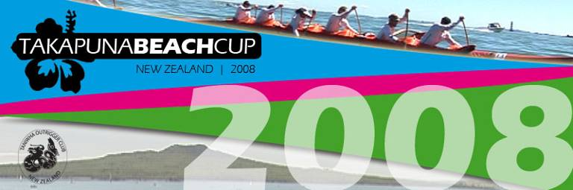

Charter Opportunity Friday 1 February 2008

Dear Sir/Madam,

Our organisation is Takapuna Beach Cup Ltd and is based in Takapuna, Auckland. We are holding a regatta at Takapuna Beach on Saturday and Sunday the 16th / 17th February 2008 for outrigger canoes. On the Saturday we hold a 42km Race with the course being from Takapuna Beach around Rangitoto, Motutapu, Rakino Islands and back to Takapuna Beach.

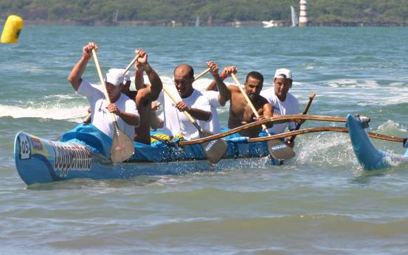

For this race we are urgently looking for Captains and vessels to support teams during the 3.5 hour race. The role involves following the crew, dropping replacement paddlers into the water (3 at a time) and picking up the resting paddlers from the sea. We are currently charging teams NZ$360 for the support boat hire for the day.

We really need to find extra support boats ( min 5.5m & 90 hp)to assist some of our out of town teams. If you have access to a suitable boat or are able to help, please email or call and let us know.
Important: payment for support boats will be received by teams around the Fri 8 February so we can notify captains, manage logistics and payment in advance of the hire.

We have crews coming from Tahiti, San Diego, the far north and the south island to participate, as well as all last years champions. We want to show them a good dose of New Zealand hospitality. On race day there will be four camera crews operating on the support boats capturing footage of the race. This year we have cameras each exclusively focussed on the women’s and men’s races. This exciting action will be available to all on Sky Sports Television in March and on the Takapuna Beach Cup DVD.

Please get in touch urgently if you can assist.

Kindest,

Lance Richards Eddie DeVries
lance@takapunabeachcup.com eddie@takapunabeachcup.com
0274427273

Nick Lowes Kingi Gilbert
nick@takapunabeachcup.com kingi@takapunabeachcup.com
0214990424 021893917

