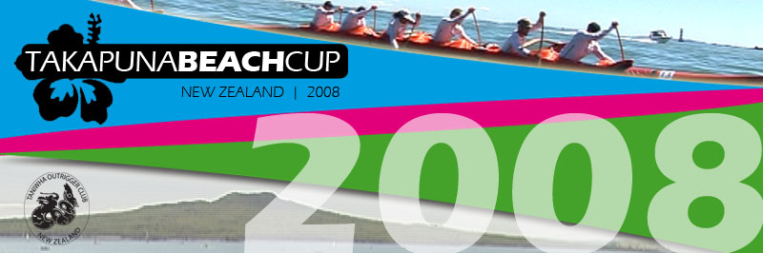

Important Update Friday 1 February 2008

SUPPORT BOATS 42KM RACE
We really need to know if your crew has a support boat or if you have access to support boats. Please email eddie@takapunabeachcup.com and let him know if you definitely have a boat and/or if you know someone who wants to act as a support boat driver.

Important: payment for support boats must be received by Fri 8 February so we can notify captains and manage logistics.

PRIZES 42KM RACE UPDATE!
We have some crews coming from Tahiti, San Diego, the far north and the south island to participate, as well as all last years champions! Who will take home the accolades? This year we have a new trophy the ‘Ken Gilbert Memorial Trophy’ for the Master Men’s division.

We can confirm that prize money will be allocated to divisions that have 5 or more teams only. We have yet to confirm prize amounts. Please note: that prizes will only be allocated where ALL team members are present and accounted for at the prize giving ceremony, that means that all nine male paddlers and all ten female paddlers must be present.

NEED A PADDLER/TEAM?
If you have trouble getting numbers for a team for the 42km race or are wishing to paddle email kingi@takapunabeachcup.com and he will try and link you in. We want everyone to participate and have a great time and a great race.

PAYMENT
When direct debiting, please remember to write in the account reference field either your team name, club name or manager name. This must be added otherwise we don’t know who has paid, we’ve had a couple come in unmarked already. Please see the website with for direct bank account details or make the cheque payable to ‘Takapuna Beach Cup’.

W1 / W2 RELAY COURSE
This course will be designed for ruddered and rudderless canoes. The race director will change the course depending on the weather conditions to ensure we can run a safe event. Remember your individual times are also calculated, so you are not penalised for being with someone slower than you.

SKY TV / DVD
On race day there will be four camera crews operating on the support boats capturing footage of the race. This year we have a cameras each exclusively focussed on the women’s and men’s races. This exciting action will be available to all on Sky Sports Television in March and on the Takapuna Beach Cup DVD. The DVD will cost $29.95 (including GST, cheaper than Hamilton Island DVD). Contact kingi@takapunabeachcup.com.

TAKAPUNA CUP OFFICIAL T-SHIRTS
This year we are letting the paddlers choose their own shirts. We have a selection of t-shirts available:

LIMITED EDITION (100) ADIDAS RACING SHIRTS! If you would like to purchase these they will be available at the main registration area for $45 incl GST.


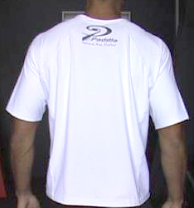
PADDLA RACING SHIRTS & CAPS! We are pleased that Paddla is assisting us to provide race gear. If your crew would like to race in these shirts please contact Nikki at xpgnz@xtra.co.nz.

