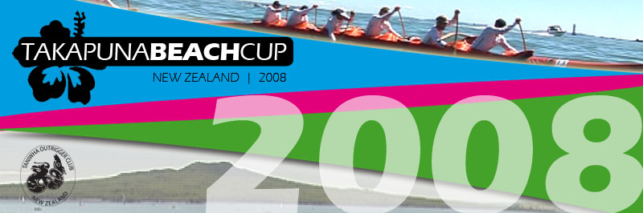

OFFICIAL ENTRY FORM
Saturday 16th February 2008
Junior Races

Distance 10km (Course map will be made available in January)

Entry Fee: $20 Per Paddler - $120 per crew, all paddlers will receive a T-Shirt & Meal voucher.
There will be a Trophy for 1st place in each category

Canoe Type: Juniors must race in 1990 Model Waka (no exceptions)
If you wish to source a Waka please contact lara@collegesport.co.nz

Spray Skirts: May be required depending on the conditions

Maximum Age: Under 19 at 1 January 2008
Minimum Age: 14 Year old at at 1January 2008.
There will be one age category of J19 – Teams can comprise of paddlers between 14 and 19 years of age.

Start: Will be 30 minutes after the Start of the Senior Takapuna Beach Cup Race

Categories:
    - Junior Men,
    - Junior Women
    - Junior Mixed (3 male, 3 female)
    - All categories will be run together

Team Name:

Club: Contact Person:

Email: Phone:

Paddlers Names
1. 2. 3.

4. 5. 6.

- Paddlers will be asked to sign a registration form on the morning of the race.
- It is compulsory that all paddlers in the Junior Race wear a life jacket.
Make the cheque payable to "Takapuna Beach Cup". Alternatively, pay by direct debit.
Bank: ANZ
Branch: Albany
Name: Takapuna Beach Cup
Acc#: 01 0277 0061164 02

Please post Entry Forms to:

Takapuna Beach Cup Ltd
PO Box 36445
Northcote
Auckland

Or Email lara@collegesport.co.nz
ENTRIES ARE DUE BY 1st February 2008
For any questions please contact lara@collegesport.co.nz

