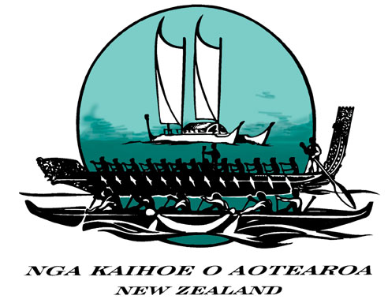

NKOA HPD Programme/ World Sprints 2008

PANUI 3 February 2008

This is an update on the process towards trialing, coaching and selection for the 2008 World Sprints.

Previous Panuis

Please see Panui 1 posted on the website September 29 2007 and Panui 2, posted November 19 2007. Information in those panuis remains relevant unless changed by the further information given in this panui.

Worlds 2008 Sacramento- Registration/ W1 Trials

Many paddlers have already completed registration and W1 trials. All these paddlers need to do is now ensure they are registered with a Regional Programme by April 1 2008.

The opportunity for other paddlers to register for the Worlds has been extended to February 25 2008. This is the last date for registration and the following two requirements must be met by that date – no exceptions.

- The paddler must have completed a W1 trial (see previous panuis for detail on how these trials are run). You need to complete an authorised trial through one of the regional coordinators. Please note that, as trials have already been held, no region is under any obligation to hold a further trial. So you cannot demand, only ask. For information contact:-

HTPWAA George Fa’alogo siaosi.faalogo@police.govt.nz
(Wellington)
TTCPA Rob Gable Robert.Gable@xtra.co.nz
(Northland)
AROCA Louise Henderson Louise.Henderson@pernod-ricard-nz.com
(Auckland)

TPTOI Howard Hyland hylandhr@xtra.co.nz
(Bay of Plenty/ Waikato/ Taranaki)

TUOTR Brian Wilson bwilson@paradise.net.nz
(Gisborne/ East Coast)
SIRWA Shaun Hardcastle Shaun.Hardcastle@baseplusworld.com
(South Island)

- The paddler must pay a $150 fee to cover the Regional Coaching Programme that will be conducted as training towards the Worlds. The fee should be paid to the Region running the W1 trial. However the fee may later be transferred if the paddler joins another Region’s Programme. The fee is non-refundable.

Regional Programmes

In addition to the requirements above all paddlers who wish to attend the Worlds must be registered as part of a Worlds Programme by April 1.

The Regions running Worlds Programmes and their head coaches are:-

TTCPA

J16 Women Dave King
J19 Women Dave King
J16 Men Ralph Ruka
J19 Men Ralph Ruka
Snr Master Women Kay Ratana & Ngaire King*
Snr Master Men Skin Atkins

AROCA

Master, Senior Master Katja Hildebrandt*
and Golden Master Women

(Note: AROCA have advised they may run other programmes, but this has not been confirmed – contact Louise for further information)

TPOTI

J16 Women Roly Puke
J19 Women Howard Hyland
J16 Men Fred Whata
J19 Men George Thomas
Master/ Senior Master Men Corrina Gage
Golden Master Women Corrina Gage

TUOTR

J16 Women Kiwi Takao
J19 Women Kiwi Takao
J16 Men Bruce Campbell
J19 Men Bruce Campbell
Open Women Kiwi Takao
Open Men Bruce Campbell

HTPWAA

Juniors Mareikura Brightwell
(Men and Women)
Seniors Brett Annan*
(Men and Women)

SIRWA

No Programme

* Note – Many regional programmes are linked to a national programme being coordinated by Corrina and Marinna, see separate panui on website)

Paddlers should contact the relevant Region’s HPD representative to make enquiries about joining one of the above Programmes.

Paddlers Without Teams

Some concern has been expressed from paddlers who have registered and trialed but who can’t see a team being formed that they can be part of. Those paddlers need to contact their regional HPD representative (see above). It is a very important part of this process that no paddler with ability to do well at the Worlds misses out. We will do our best to see if we can form teams, even if this involves co-ordinating across the country.

Qualifying Trial for the Worlds

The various Regional Programmes will train teams towards the Worlds Qualifying Trials. These are to be held at Lake Karapiro on 10 May 2008. W1s will also trial on that day.

Please Note: The previously advertised regatta to be held at Karapiro end of March has now been cancelled.

If you have any other query please contact your local HPD representative or the HPD Convenor, Peter Reaburn (peterr@catobolam.co.nz) or Maggie Greening, President NKOA (maggiegreening@extra.co.nz).

NKOA HPD Committee

