Nga Kaihoe o Aotearoa Inc.

Annual General Meeting
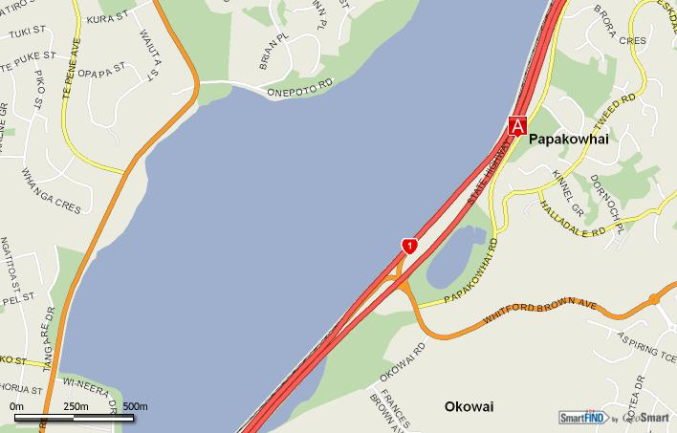

Saturday 30th August 2008
12.50 am Assemble in car park
New Zealand Royal Police College Marae
Papakowhai Road
Porirua
- Royal NZ
Police College

AGENDA

- Powhiri/Whakatau
- Kapu Ti
- Meeting open / Mihi / Welcome
- Annual Presidents Report
- Minutes of Previous AGM
- Financial Report
- Appointment of Auditor
- Activity Reports from Council
  - National Club Sprints 2008
  - National Secondary Schools 2008
  - Worlds 2008
- Affiliation Fee
- Announce the new Council Executive for next term
- General Business
  - Rule remits
  - Council Meeting Dates
12. Close of meeting / Kapu Ti

