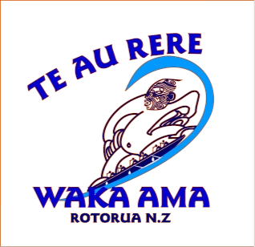


Twilight Paddle (Updated)

5k and 8k – 7 October 08 to 11 November 08

Person In Charge:
Renee McDonald

Venue:
Lakefront – Rotorua

Timetable:
5.30pm Registration

5.45pm Race brief
Safety check – (spare blade, sprayskirt , bailer, life jacket)

5.50pm on the water

6.00pm races will start

Contacts:
Renee McDonald - 0273253450
Mala Grant – 0274153171

Cancellations:
Phone 021 872 661 after 3.30 pm on the day of twilight paddle for
answerphone message.

Points System:
A points system will operate for the series of 6 races.

5.00 pays for a safe and organized race !!

_____________________________________________________

