 PADDLE SUMMER 2009
V1 | V2 | OC1 | OC2 | SURF-SKI | KAYAK | STANDUP

UPDATE 2: KIA ORA EVERYONE!
Thanks everyone! We had a really positive response to the survey. We received 70 positive responses. Therefore, as promised we are going to organise this series of races. We really need volunteers, support boat drivers and any sponsors to come forward now, so please email us kingi@whakarongo.com or magicevents@clear.net.nz.


SURVEY SUMMARY
- Overall we had responses from 17 surf-skis, 28 rudderless V1, 46 ruddered OC1, 10 stand-ups, 8 OC2 and 3 kayak paddlers.
- 50% of you told us that you wanted to do downwind runs, 10% percent wanted to do short course and 40% would do any course.
- Prices: 68% wanted to pay between $20 to $30 for their race fees; 80% of you said that you would buy your own race t-shirt at $25-$35 and 85% said would pay for kai afterwards.
- Most of you preferred to paddle in Auckland, with Raglan, Northland, Tauranga and Coromandel coming in strong seconds for big races.
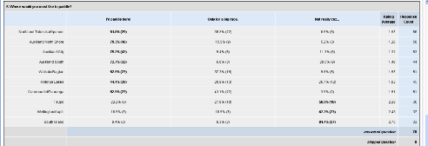
Overall, most were very supportive of the series! Choice! Thank you!
RACE DATES:
Here are the suggested race dates we are looking at:
Race 1 Sunday 26th January 2009 Auckland Anniversary
Race 2 Sunday 1st February 2009 Day after KingHarbour
Race 3 Sunday 1st March 2009 TBC

RACE PRICES:
Due to administration we need all people registered and paid by the Wednesday before race day (via direct debit).

Pre-race entries by Wednesday $25
On the day (closes 10:30am) $35

WEBSITE:
The website is currently being developed at www.hoetoa.com

RACE COURSES:
Because this race is downwind focussed, we have devised three Auckland based courses that range around 20km. There is a relay option for each of these courses, should you wish to partner with someone else. Please provide feedback so we know what you prefer.

Race Course 1 North, North Easterlie & South
Long Course: Whangaparaoa to Narrowneck 22/24km
Relay Course: Leg 1: Whangaparaoa to Rothesay Bay 13km
Leg 2: Rothesay Bay to Narrowneck 11km
Short Course: Rothesay Bay to Narrowneck 11km
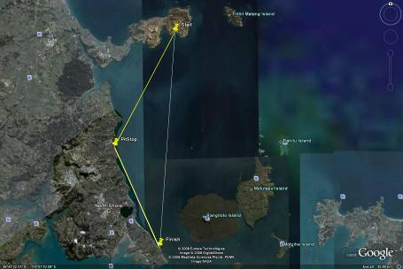
Race Course 2 City Side: Westerlies & Easterlies
Long Course: Maraetai to Orakei 22km
Relay Course: Leg 1: Maraetai to Eastern Beach 12km
Leg 2: Eastern Beach to Orakei 13km
Short Course: Eastern Beach to Orakei 13km
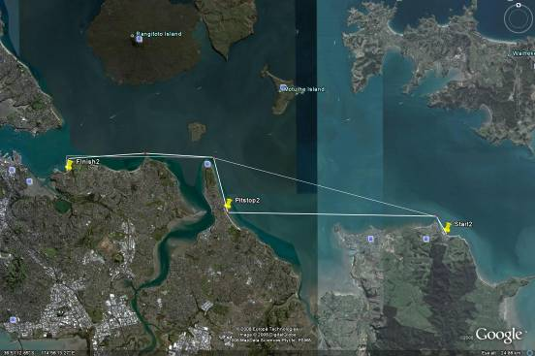

Race Course 3 Westerlies: Waitakere to Narrowneck (least)
Long Course: Herald Island/Te Atatu to Narrowneck20km
Relay Course: Leg 1: Herald/TA to Birkenhead 10km
Leg 2: Birkenhead to Narrowneck 12km
Short Course: Birkenhead to Narrowneck 12km
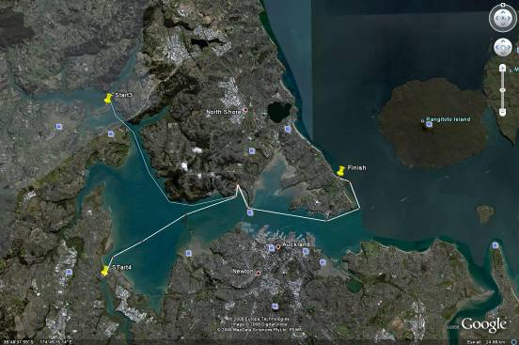
TRANSPORT TO & FROM RACES

It is up to the paddlers to arrange their own car pooling as we do not have facilities to transport 70 canoes. We are hoping to arrange a trailer for a limited amount of canoes if people get stuck they can hopefully book space on trailer in advance for a fee of around $15 per canoe, it depends on what the driver wants.

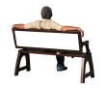
SPONSORS
We have one sponsor (Ignite Studios Ltd design). We’d like to know if you or a friend might like to sponsor some prizes, paddles, transport costs anything that you think paddlers might need. Please contact kingi@whakarongo.com.
- Sausage Sizzle – sausages, BBQ machine, bread, onions, sauce
- Race T-Shirts
- Petrol or Gift Vouchers for support boat drivers
- Hats, cups, spoons, airfares, drinks, fruit, apples
- Paddles, drink systems, sunblock, gel packs and supplements


PRIZES
We are looking for prizes to give away as spot prizes and major prizes. There will be series champions as well as race champions.

RACE SHIRTS
We are doing standard race tops (green), yellow leaders and organe runners-up. Categories must have more than 15 entries to qualify for coloured leaders tops, these are the current categories, please encourage your friends to enter!
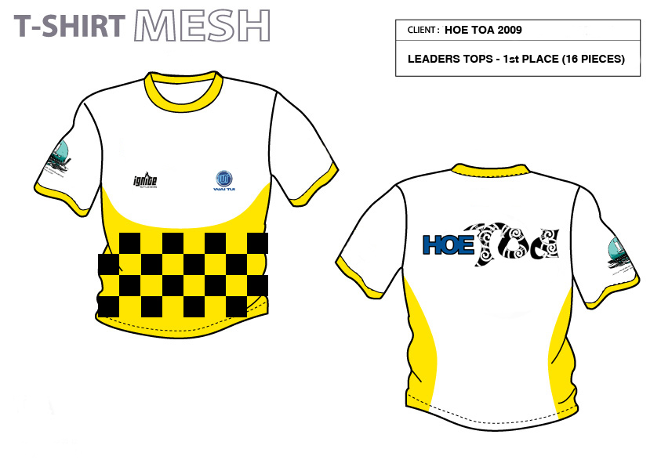
- MENS V1 OVERALL
- MENS OC1 OVERALL
- WOMEN OC1 OVERALL
- MENS SURFSKI OVERALL
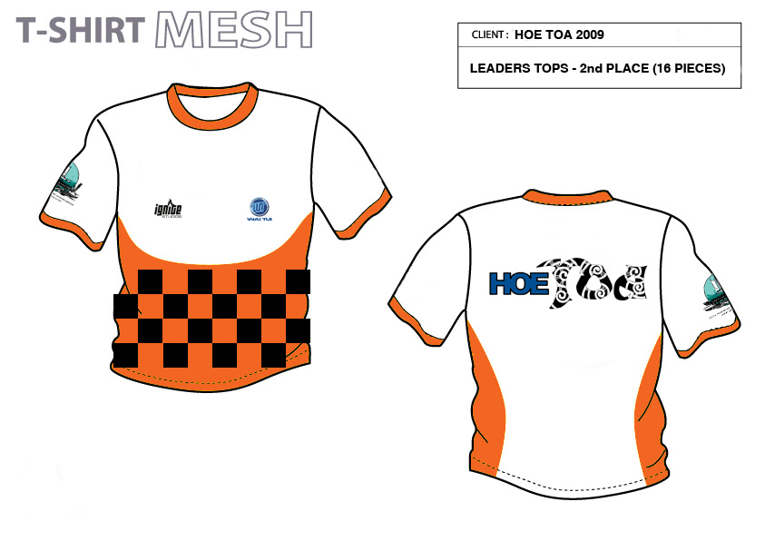
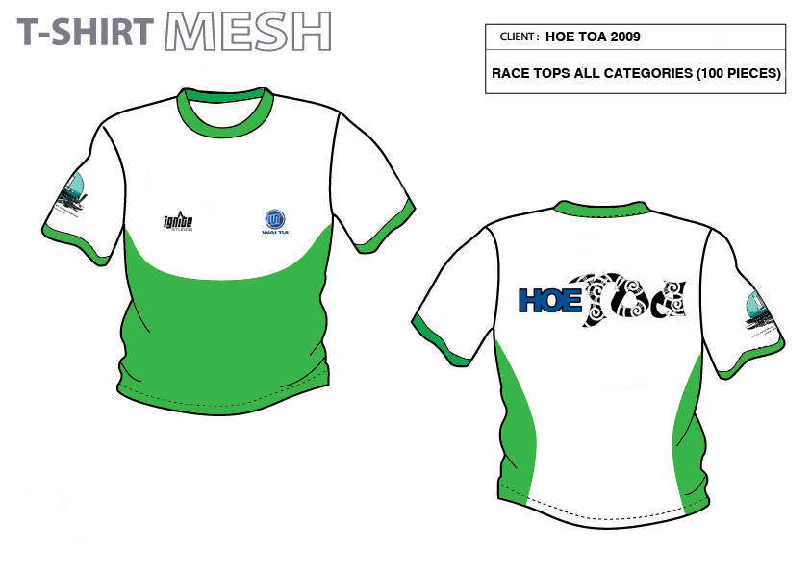
SUPPORT BOATS:
We are looking for two support boat drivers to compliment our jetski’s in support. A boat must at least be able to take one busted two-man and its two paddlers back to shore. You are paid the day before 50% and upon completion the remaining 50%. Obviously if we are short of paddlers or weather permits we won’t go ahead with the race, but you will be advised on the Saturday before racing.

SAFETY & RULES:
All paddlers will have to sign a waiver, have spare paddle, life flotation device, have an emergency contact phone number, their own proof of insurance and have their allocated number on their canoe. We do this to make sure that if you get into trouble we can call someone and you are looked after properly.

RACE TIME:
Races will start at 11:00am on the race day. Check-in closes at 10:30am – if you miss that time sorry (aroha mai).

FACILITATORS/ORGANISERS:
Please contact us if you are able to help in anyway with sponsorship, prizes, BBQ sizzle or support boats.

Kingi Gilbert kingi@whakarongo.com at 09 486 1598 or 021 893917
Phil Briars magicevents@clear.net.nz at 021 626 713

Once again, thank you to all the paddlers who offered us their thoughts, support and whakaaro. Nga mihi mui koutou!
Kia ora & thank you

A Race Series for New Zealand Summer, bought to you by:


