
Takapuna Beach Cup 2009
Junior Race 2009

Kia ora Koutou

We have received the following entries for this year Takapuna Beach Cup Junior Race:

Taniwha | Grizzlie Juniors | 1 | Junior Men
Portage Crossing | Ugliez | 1 | Junior Men
Taniwha | Grizzlie Juniors | 1 | Junior Mixed
Taniwha | Grizzlie Juniors | 1 | Junior Women
Tamaki Outrigger Canoe | Team Pulse | 1 | Junior Women

Race Registration: commences at 7:00am at the Takapuna Boating Club.
Teams must all register and complete the attached Registration Form
Maximum Age: Under 19 years old at 1 January 2009
Minimum Age: 14 years old at 1 January 2009.

Each Paddler will receive a T-Shirt. – These can be collected at completion of registration

Karakia: will take place on the beach at 8am for the Junior race.

Race Briefing: will take place on the beach after the Karakia.

Race Course will be similar to the map below – a 5km Triangle that teams must complete twice. Course direction will be determined after conditions have been assessed on the mo0rning of the race.
All categories will be run at the same time.

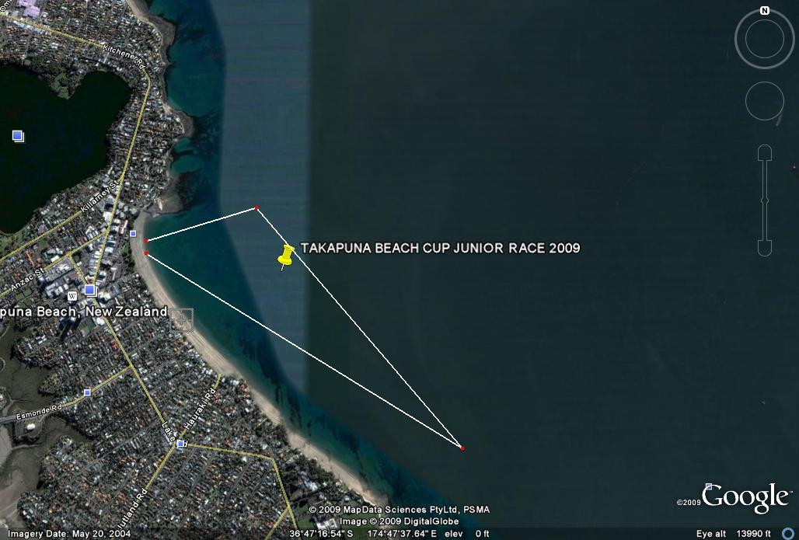

SAFETY
All crews must adhere to the safety Check. Officials will be visible and will complete
Safety Check.

Safety Equipment must include the following:

YES
SPRAY SKIRTS

LASHINGS SECURE

SPARE PADDLES [2]

LIFEJACKETS/FLOTATION DEVICES [6]
THESE MUST BE WORN DURING THE RACE
BAILERS [2]

BUNGS

TOW ROPE [SECURED CORRECTLY]

RACE START: Will be at 8:30AM - Start procedure will be outlined at the race briefing.

PRIZEGIVING: Will take place on the beach prior to the Senior Race Commencing.

For any Queries please contact Lara Collins 0275484612

