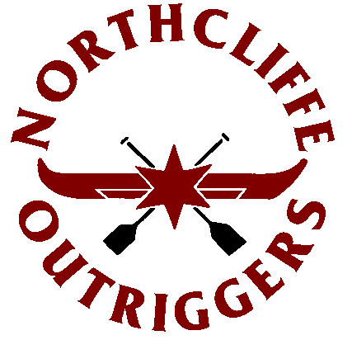 | Northcliffe Outrigger Canoe Club  Po Box 6350  Gold Coast Mail Centre 9726

13 February 2009

ALL OUTRIGGING CLUBS IN AUSTALIA & OVERSEAS

Dear Club President

Northcliffe Outrigger Canoe Club takes great pride & pleasure in inviting members from your club to compete in the 14th Annual 43km GOLD COAST CUP to be held on Saturday 18th April 2009.

Saturday morning showcases the Gold Coast cup ultra marathon OC6 changeover (9 men, 10 women, 5 men and 5 women mixed crews). This race is set up to maximise the best paddling conditions available on the Gold Coast. Canoes will be set up on beautiful Greenmount Beach, at the southern end of the Gold Coast for a staggered start time of 8.00am for all Women’s & Mixed Crews, followed by all Men’s divisions start at 8.30am. This should create very exciting racing especially towards the 2nd half of the race and finish line when some crews from the 2nd start attempt to chase down those crews in front.

Lined up for the start off Greenmount point, crews race South to the first changeover point (buoy) situated just off Cook Island, then head North along the spectacular Gold Coast beach line past Surfers Paradise to the Gold Coast Sea way. Once through the Sea way, crews continue the dash home in the Broad water for a final flat water sprint to the finish line in front of the Northcliffe Outrigger Canoe Club container (Air sea rescue car park). There will be a HUGE AFTER PARTY ON SITE approx. 1 hour after the final crew crosses the finish line. Multiple RANDOM Draw prizes on offer including a New STEALTH OC1 to be given away to one lucky paddler.

Please take the time to view the attached Event Promotional Poster that provides basic information of the event including the announcement of over $20,000 in cash and Prizes to be won.

Further information concerning the race can be obtained at the dedicated web site: www.goldcoastcup.com

PLEASE NOTE: all nominations for this race MUST be made online via the AOCRA web site at: www.aocra.com.au

We look forward to seeing you at the 2009 Gold Coast Cup and experiencing Australia’s Longest OC6 Changeover Race…

Regards

Lesley Gillgreen
President
Northcliffe Outrigger Canoe Club
PO Box 6350
Gold Coast Mail Centre 9726 Qld

Andrew Paul
Event Manager – The 2009 GOLD COAST CUP
Northcliffe Outrigger Canoe Club
Email: eightball1970@hotmail.com
Mob: 0410 443141

