2010 World Sprints – Noumèa, New Caledonia

INTENT TO PADDLE AT THE 2010 WORLD SPRINTS FOR SENIOR DIVISION CREWS
Interested persons are required to submit an Intent to Paddle Sprints Form to be considered to paddle as a Senior Competitor (Open, Master, Senior and Golden Master), both men and women, for the 2010 World Sprints.
All applicants must be affiliated to NKOA before they are accepted into the programme
For more detail about the selection process, go to the Selection Process Paanui on the Waka Ama website.
Complete the Intent to Paddle Sprints form below and email to admin@wakaama.co.nz by Tuesday 14th April.
Or post to:
Intent to Paddle Sprints
Nga Kaihoe o Aotearoa
PO Box 45084
Waterloo
Lower Hutt 5042
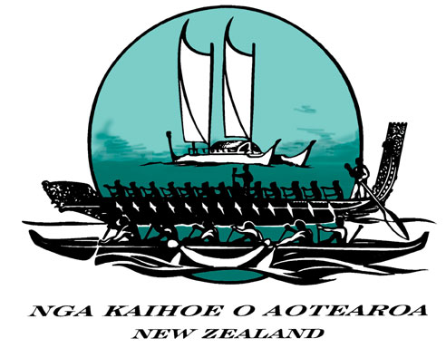 National 2010 World Sprints Campaign

Senior Intent to Paddle Sprints Form
One form per paddler

First Name  (as stated on Passport) |  | NKOA number  (contact your regional coordinator if unknown)
Surname  (as stated on Passport) |  | Age  (as at May 2010)
Email Address |  | Club
Region (preference for training purposes) |  | Are you able to steer a competitive crew?
Cellphone: |  | Preferred seating position (in order).
Alternative Phone: |  | Preferred seating position (in order).
Best way to contact you – text or email? |  | Passport Number

Highlights of successes relative to sprints
1
2
3
4

Any other comments to support Intent:

