2010 International Long Distance Events

INTENT TO PADDLE LONG DISTANCE 2010
Interested persons, both men and women, are required to submit an Intent to Paddle Long Distance form to trial for New Zealand long distance squads. The trial is for an Open Mens squad and an Open and Masters womens squad. The selected mens crew will go to the Hawaiikinui race 2010 and the womens selected crews will go to the Na Wahine o Ke Kai (Molokaii) race 2010.
For more detail about the selection process, go to the Selection Process Paanui on the Waka Ama website.
Complete the Intent to Paddle Long Distance form below and email to admin@wakaama.co.nz by Friday 1st May.
Or post to:
Intent to Paddle Long Distance
Nga Kaihoe o Aotearoa
PO Box 45084
Waterloo
Lower Hutt 5042
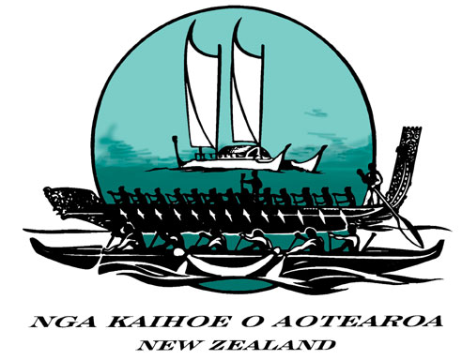 National 2010 International Long Distance Campaign

Intent to Paddle Long Distance Form
One form per paddler

First Name  (as stated on Passport) |  | NKOA Number
Surname  (as stated on Passport) |  | Date of birth
Email Address |  | Cellphone:
Region (preference for training purposes) |  | Alternative Phone:
Passport Number |  | Passport Expiry Date

Highlights of successes relative to Long Distance
1
2
3
4
5
6

Any other comments to support Intent:

