
In July the 4 winners of the Air Tahiti Nui Aotearoa Aito traveled to Tahiti to compete in Te Aito!
Leanne Haronga, Rose King, Hemi Wahapango and Tyrin Thomas won the opportunity to travel to and compete in the Worlds biggest Va’a race!
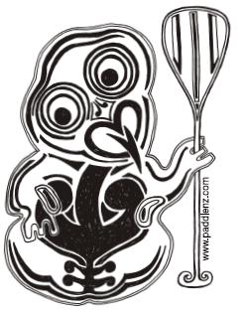
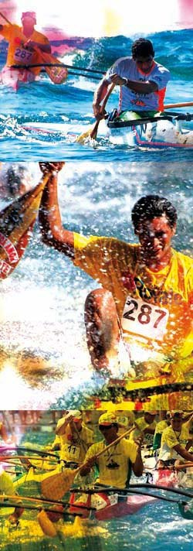
Air Tahiti Nui sponsored the flights, The Hort family in Pt Venus, Mahina opened their home and their hearts to us all and the Brasserie De Tahiti sponsored all our hydration for the week. It was a dream trip and we were all very lucky to receive such amazing support!

Kinu Lucas organised canoes for everyone to race in and Leanne had a special custom made Timi Va’a made especially for the race to paddle.
The Hort Family live at Pt Venus beach which is also the sight of the Te Aito race and so everyone was able to practice all week on the course in their Va’a. Couldn’t ask for more!

Charlie Maitere - Race organiser of Te Aito made sure everyone was well briefed on the course and welcomed the Aotearoa contingent with much enthusiasm. We received media attention both in print and the evening news.

Nothing could have prepared us for the hospitality we received and the magnitude of the event that our paddlers were taking part in.

On Friday 10th July there were 103 Junior Men and 40 Women who raced and on Saturday there were 72 - 8 to 14 year olds who raced in the morning and 582 Senior Men in the afternoon!. A total of 797 paddlers in total.
A totally amazing site to see!

The standard of Paddling was intense! Te Aito has been run for 22 years and according to the race organisors the level of competition gets better and better every year! Our paddlers learnt so much from the experience and will be stronger for it! There is nothing that can prepare you for racing against 581 other paddlers on a 14km circuit. You have to do just do and learn from your mistakes. Tyrin said “At home if you make a mistake 1 or 2 paddlers may pass you. But in Te Aito if you make a mistake you may get passed by 30 guys! …unreal”

As well as the 4 winners from the Aotearoa Aito we were joined by Dave King, Rudolph Berking-Williams and Jackson Tamaariki-Campbell who all raced.
The New Zealanders who attended Tahiti for Te Aito 2009 were; Tyrin, Leanne, Rose, Hemi, Dave, Steve Haronga, Rudolph, Jackson. Donna Tamaariki, James Campbell, Dallas Ashmore & Lara Collins.

Placings:
Leanne 9th (1.25.24)
Rose 23rd (1.30.34)
Tyrin 203rd (2.43.38)
Hemi 58th (1.20:04)
Rudolph 321st (2.52.48)
Jackson 72nd (1.21.58)
Dave 428th (3.05.53)

Full results can be viewed at http://www.ftvaa.pf/index.php?num=22&choix=25

A very big thank you to Air Tahiti Nui, Brasserie de Tahiti, Hort family of Pt Venus, Charley & Bridgette, Kinu Lucas, Jas, Josie Neagle and Timi Vaa!

We will host another Aotearoa Aito in 2010 and look forward to the 23rd Edition of Te Aito in July 2010! www.aotearoaaito.com







